**5a)**

Implementation of logistic regression classifier has been done and then model is trained on data given using parameters of learning rate=0.1, iterations=400(assumed).

Here I have Initialised weights and bias to zero.

After performing the iterations the final weights and bias value, accuracy achieved on train and test data is as follows:

implementation-5.PNG

**5b)**

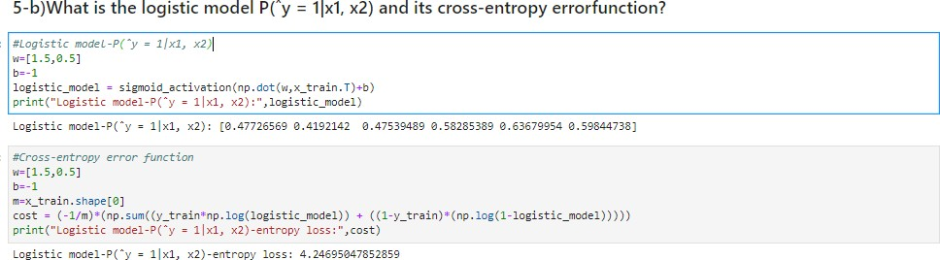

## **5c)**

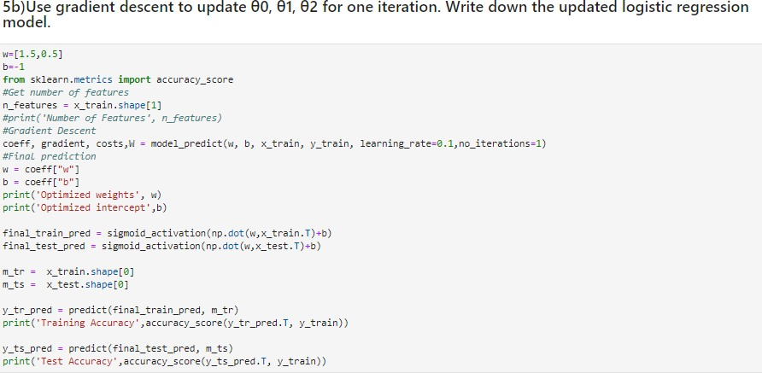5c1.PNG

5d) At the convergence of gradient descent the model has been used to make predictions on test data and the following is the accuracy, precision and recall achieved:

